# Test case scenario:

1. At the front end, customers can add the items into the shopping cart by clicking the Add to Cart button.
2. going to the checkout page, Customer fills in their shipping address and selects the payment method (the title as you defined in the configuration).
3. Going to place order page and click place order
4. Application Flow will be started, and after the customer completes the flow, they will be redirected to the confirmation page in case all good, or the customer will be redirected back to the checkout page with displaying a failure popup for lightbox case or out of the box error in case same tab.

Below screen shots for more clarification:

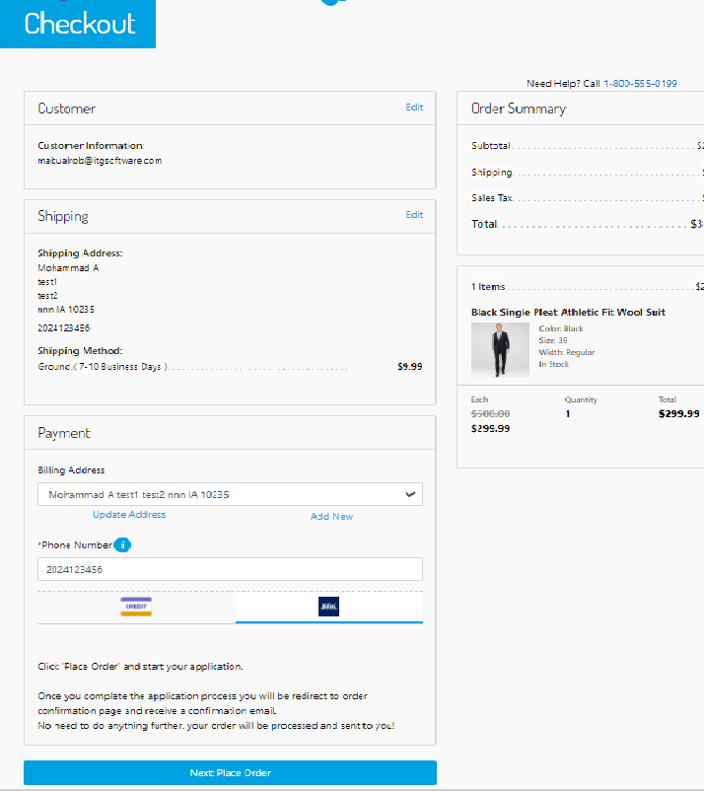

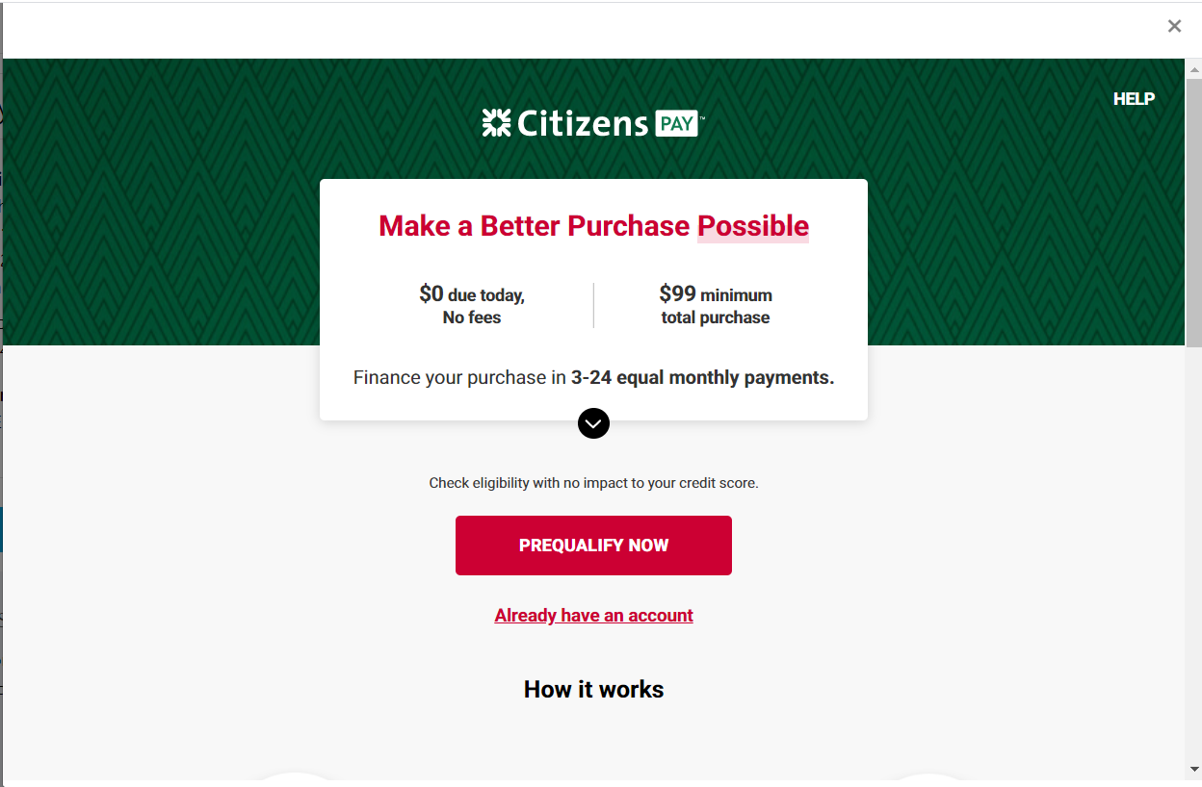

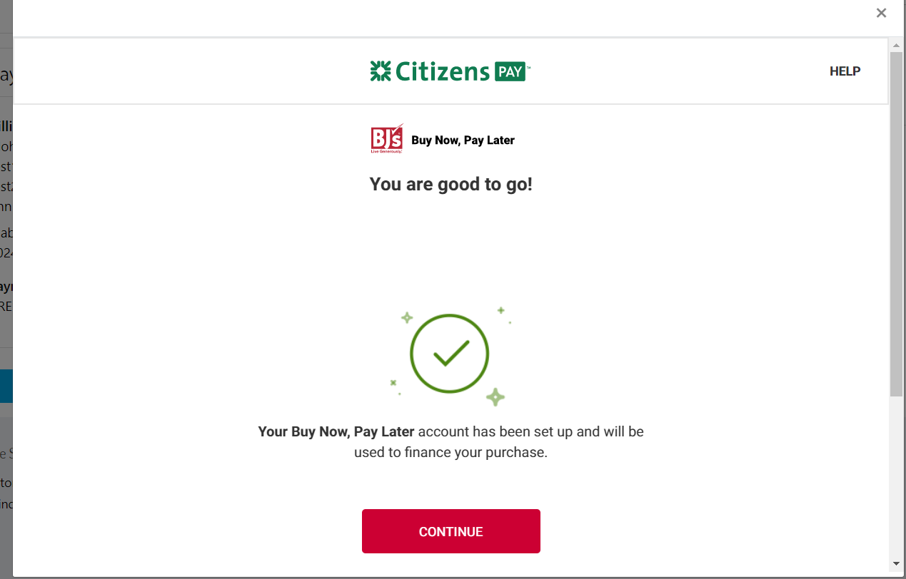

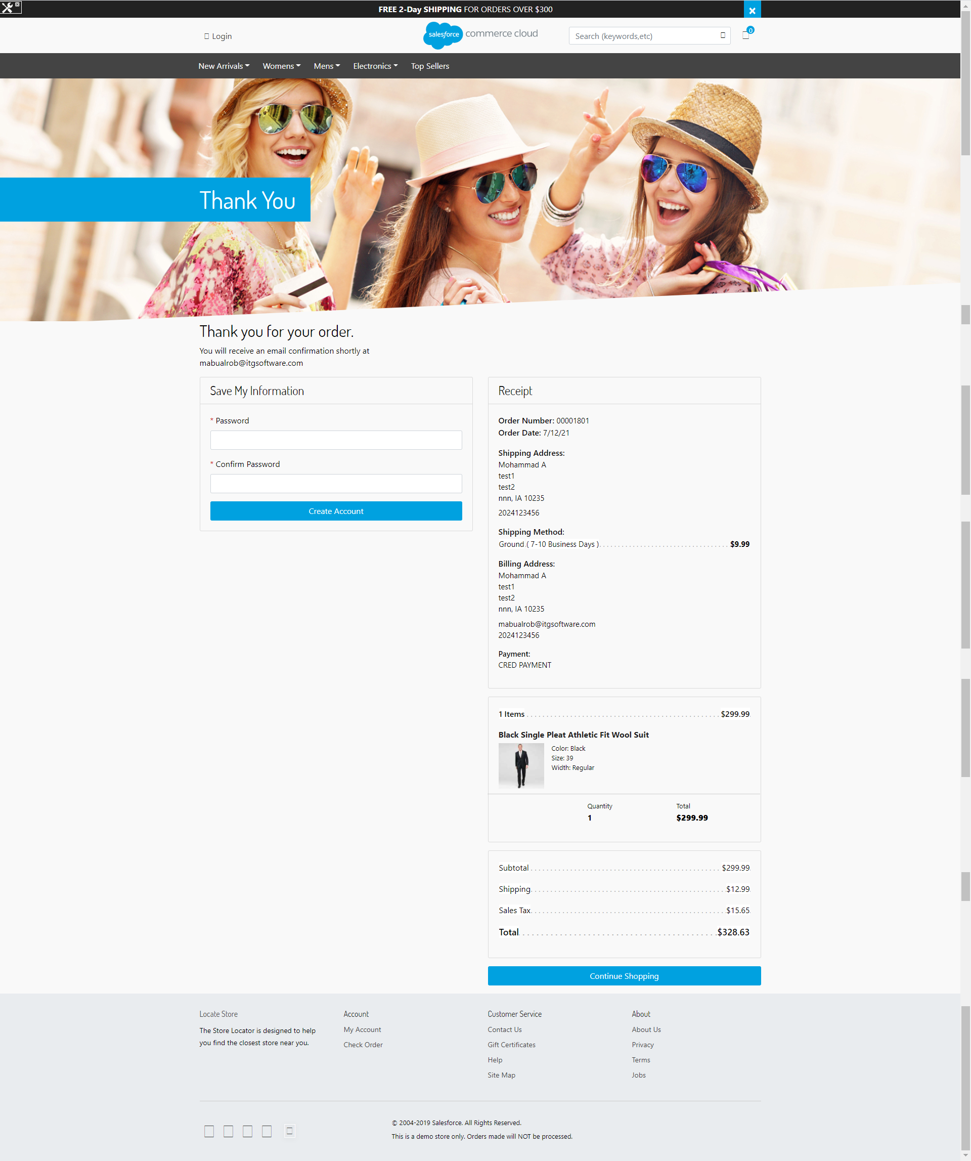

Example of the UX for an unsuccessful application here:

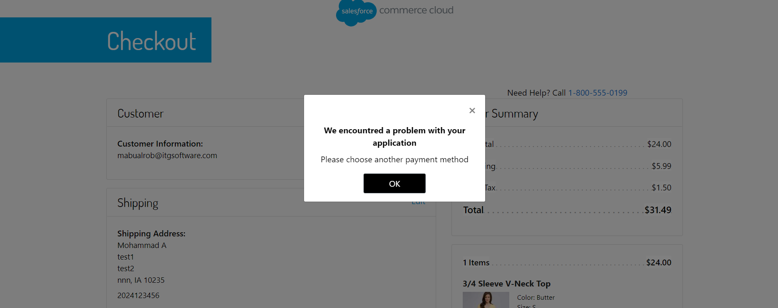

Notes

* for successful case make your order total more than 99$ eg.110 . Once application flow starts as appear in screenshots above   
  Use already account and fill below information:  
  WILLIAM YYHSST 09/28/1935 8557
* after finish the application flow will be redirected to confirmation page
* for declined case make your order total less than 99$ eg.110. Once application flow starts as appear in screenshots above   
  Use already account and fill below information:  
  WILLIAM YYHSST 09/28/1935 8557
* after finish the application flow will be redirected to payment page with proper error message